Representative:

Update Collection by Requisitions

Click “Update Collection by Requisitions” link from menu to view collection list show by requisitions id.

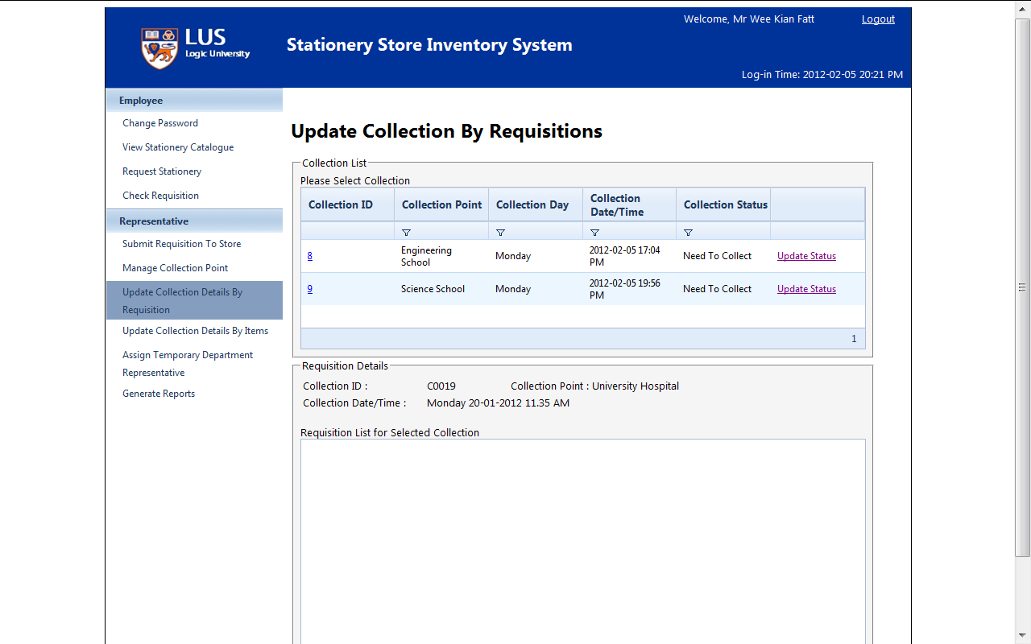

Click “Update Status”

(s)

Click collection ID and view requisition detail

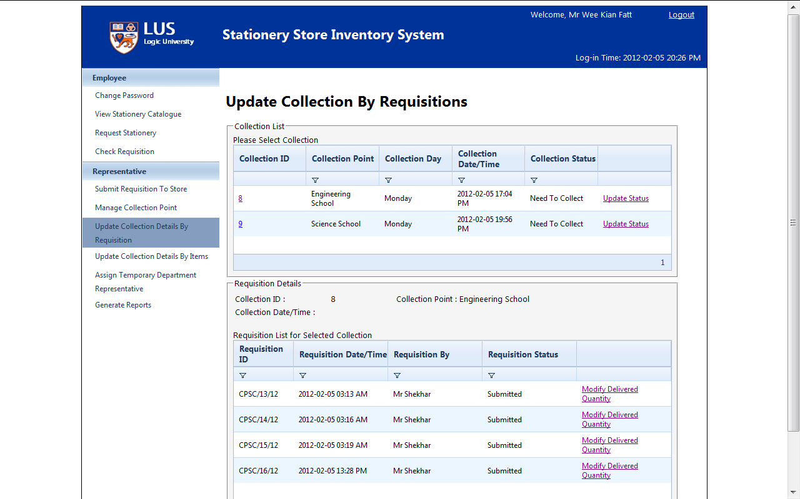

Click “Modify Delivery Quantity” and give delivery quantity

(s)